Carer's Guide- How to access PrescQIPP Care Homes Training Packages part 1&2

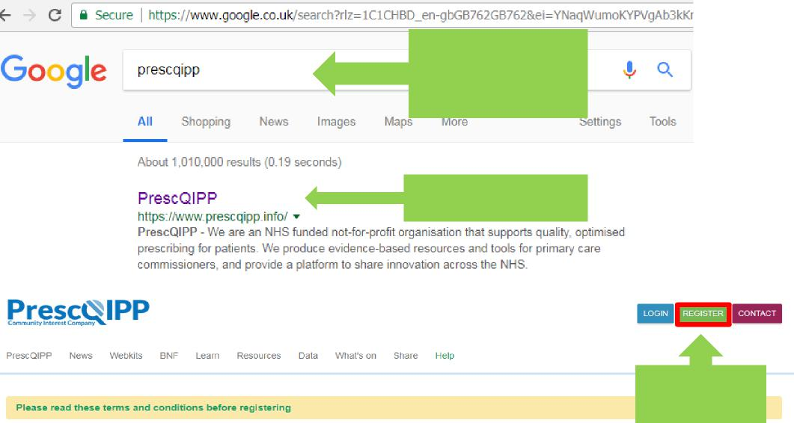
Launch the internet
and type ‘prescqipp’
into the search box.
Select the website.
Select Register.
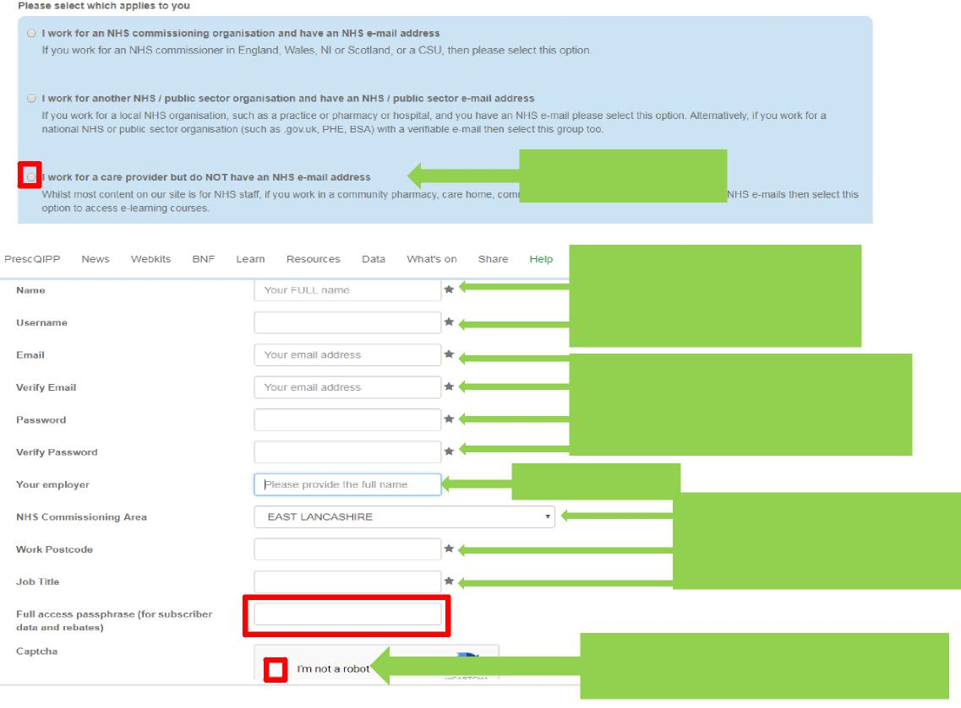
1 | Page
Leave blank
Care home name
Select the 3rd option.
Enter your full name then select a username (follow the on screen guidance for this part).
Once your email & password details have been completed enter the name of your CARE HOME.
Select and follow on screen prompts, then click the ‘REGISTER’ button
Select ‘EAST & North Hertfordshire’ from
the drop down list, then enter
your work postcode & Job title.
Part 1 – Registration.

Carer's Guide- How to access PrescQIPP Care Homes Training Packages part 1&2 Part 2 – Log in guide. Once logged in, select the following:

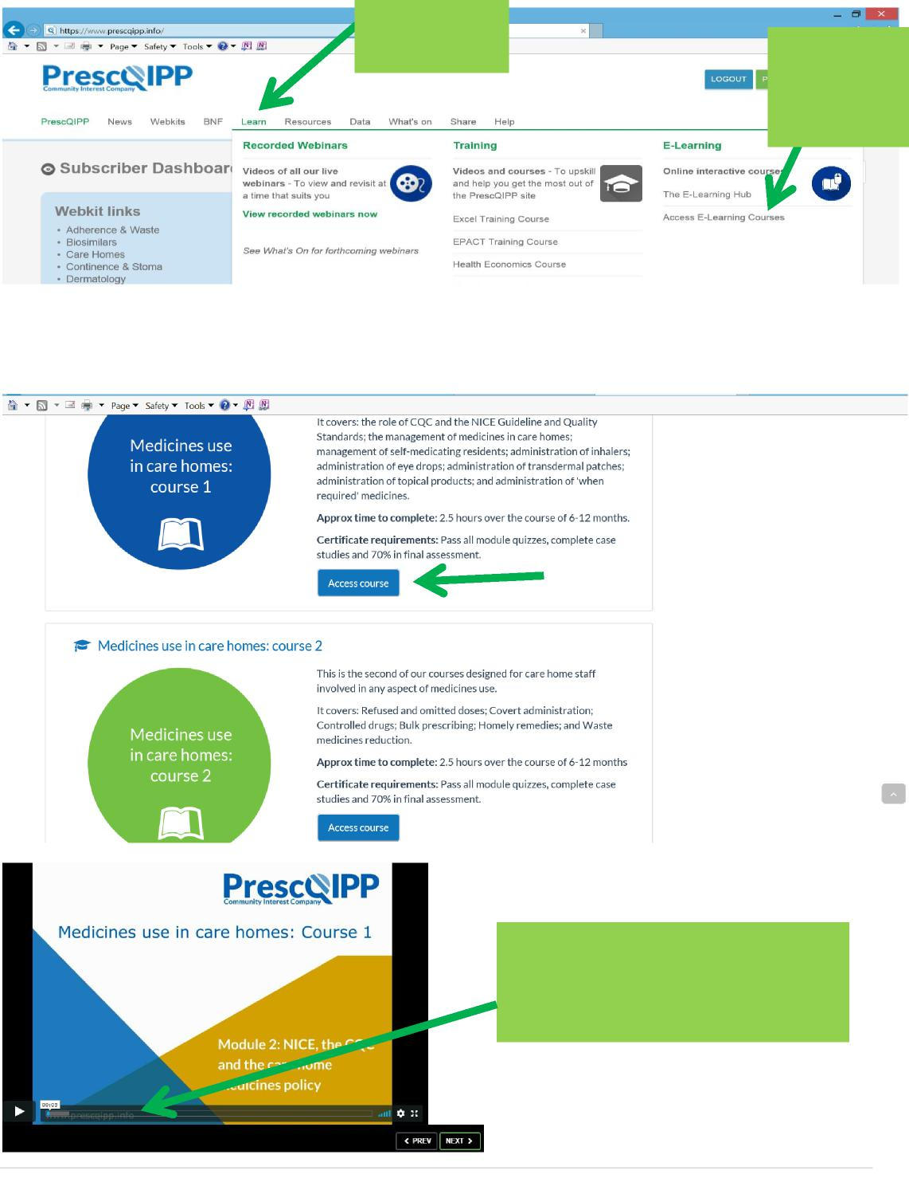
The sound may be muted. Drag
the bar along to fast forward if
necessary.
2 | P a g e
Select “Learn” first.
Select “Access E-Learning Courses.”

