PATIENT SAFETY ALERT
Introducing New Liquid and Food Descriptors for patients on modified consistencies and textures

Do your patients have swallowing difficulties?

Do they use thickened liquids or have a modified food texture?

From April 1st 2018 in line with the International Dysphagia Diet Standardisation Initiative (IDDSI) the words used to describe modified food and liquids are changing. This will affect people who have swallowing difficulties.
Old Descriptors
The New IDDSI Framework
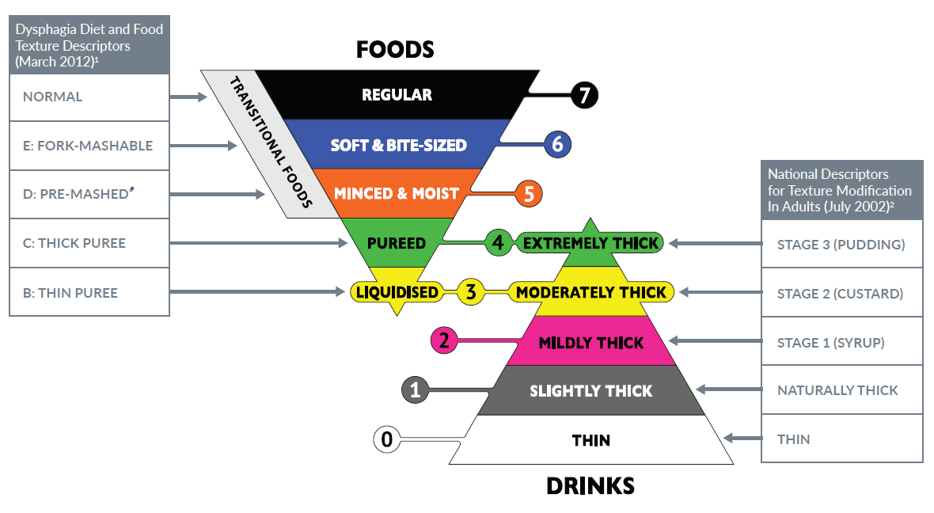
Old Descriptors
Because the labelling on the thickener product and some foods are changing there will be a transition period where swallowing recommendations made by the Speech & Language Therapist will show both the old and new descriptor names.

Be extremely vigilant when following the recommendations made by the Speech & Language Therapist, particularly for liquids, due to the similarity between old and new guidance.

Nothing else is changing: the thickener product (Resource ThickenUp Clear) and scoop sizes are staying the same but dosages are measured against 200ml rather than 100ml. If you use an alternative product then speak to your Speech & Language Therapist.
For more information contact the Speech & Language Therapy service:
East & North Herts, Lister Hospital 01438 285287
West Herts, Watford General Hospital 01923 217477

