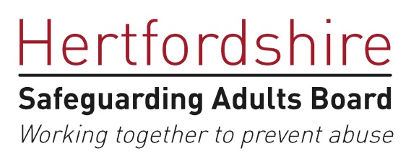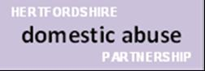

SAFEGUARDING CONFERENCE FOR
HOUSING PROFESSIONALS

Key Note Speakers on
Childhood Neglect, Hoarding, Domestic Abuse,
Cuckooing and County Lines.
Workshop Themes include:
Mental Capacity, Modern Slavery
Early Intervention: safeguarding children,
Safeguarding People with Learning Disabilities

Monday 7th October 2019
09:30 to 15:30 (09:00 registration for a 09:30 start)
Hertfordshire Development Centre
Robertson House, Stevenage
*Spaces are limited*
To book a place, please press control and click on the link below:

https://hscb.event-booking.org.uk/event-detail/==ANzAzN/Safeguarding-Conference-for-Housing-Professionals

